Forking Workflow

What is Forking Workflow?
# Source: AI Source: Provided by: [Data Path: Persons Table -> ID Column: 1, Name_En Column: Motasem Essam] -> From: [ChatGPT] on [2/15/2026]
Forking Workflow is a Git collaboration model where developers do not directly push changes to the main repository.
Instead, each contributor creates their own copy of the repository (called a fork), works independently, and then submits changes back to the original project through a Pull Request.
This workflow is commonly used in open-source projects hosted on platforms like GitHub and GitLab.

How It Works
# Source: AI Source: Provided by: [Data Path: Persons Table -> ID Column: 1, Name_En Column: Motasem Essam] -> From: [ChatGPT] on [2/15/2026]
- A developer forks the original repository (creates a personal copy).
- The developer clones their fork locally.
- A new branch is created inside the fork:
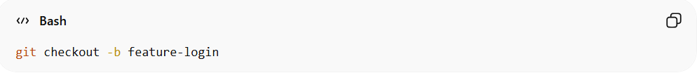
git checkout -b feature-login
- Changes are committed and pushed to the developer’s fork:
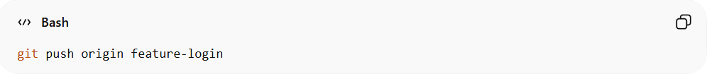
git push origin feature-login
- A Pull Request (PR) is opened from the fork to the original repository.
- Project maintainers review and approve the changes.
- If approved, the changes are merged into the main project.

Conceptual Visualization
# Source: AI Source: Provided by: [Data Path: Persons Table -> ID Column: 1, Name_En Column: Motasem Essam] -> From: [ChatGPT] on [2/15/2026]
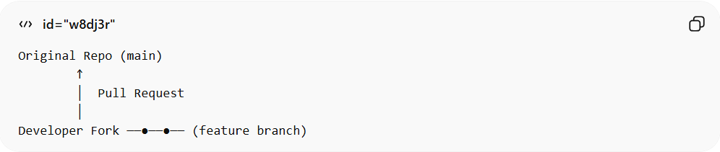
Original Repo (main)
↑
│ Pull Request
│
Developer Fork ──●──●── (feature branch)
Each contributor works independently in their own repository copy.

When It Is Used
# Source: AI Source: Provided by: [Data Path: Persons Table -> ID Column: 1, Name_En Column: Motasem Essam] -> From: [ChatGPT] on [2/15/2026]
- Open-source projects
- Large public communities
- Projects with many external contributors
- Situations where contributors should not have direct write access

Advantages
# Source: AI Source: Provided by: [Data Path: Persons Table -> ID Column: 1, Name_En Column: Motasem Essam] -> From: [ChatGPT] on [2/15/2026]
- Strong security (no direct access to main repo)
- Safe for open collaboration
- Maintainers control all changes
- Scales well for large communities

Disadvantages
# Source: AI Source: Provided by: [Data Path: Persons Table -> ID Column: 1, Name_En Column: Motasem Essam] -> From: [ChatGPT] on [2/15/2026]
- More complex setup
- Requires managing upstream repository updates
- Slightly slower contribution process

Key Idea (Exam Summary)
# Source: AI Source: Provided by: [Data Path: Persons Table -> ID Column: 1, Name_En Column: Motasem Essam] -> From: [ChatGPT] on [2/15/2026]
Forking Workflow = Each contributor works on their own fork → submits Pull Request → maintainers review and merge.
It is the preferred workflow for open-source and large public projects.

